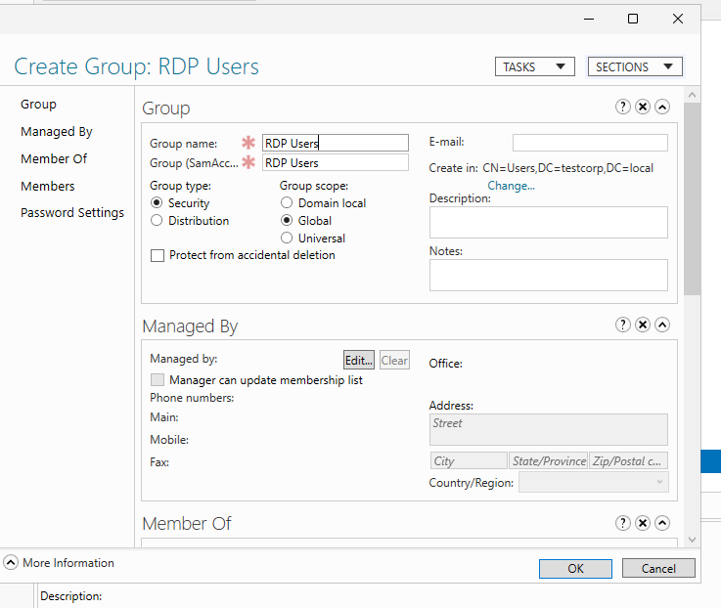
Organizational Units, Groups, and Group Policy Objects
A separate Group Policy Object (GPO) was created, independent of the main domain policy, to manage Remote Desktop Protocol (RDP) access. A security group named RDP Users was created, and the user TestUser was assigned to this group.
PowerShell command used to create the RDP Users group:
New-ADGroup -Name "RDP Users" -GroupScope Global -GroupCategory Security -Path "CN=Users,DC=testcorp,DC=local"
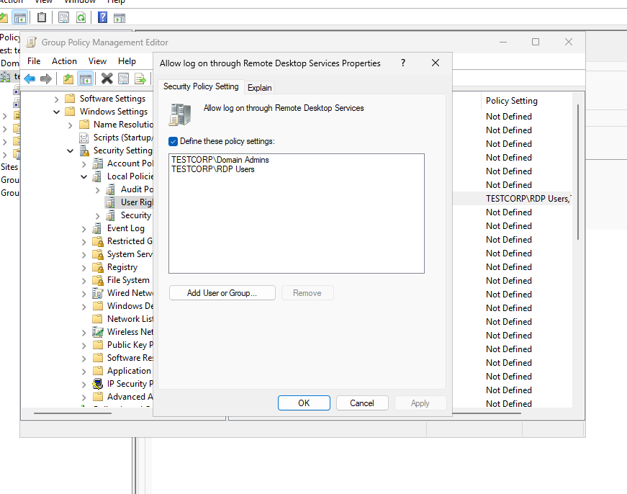
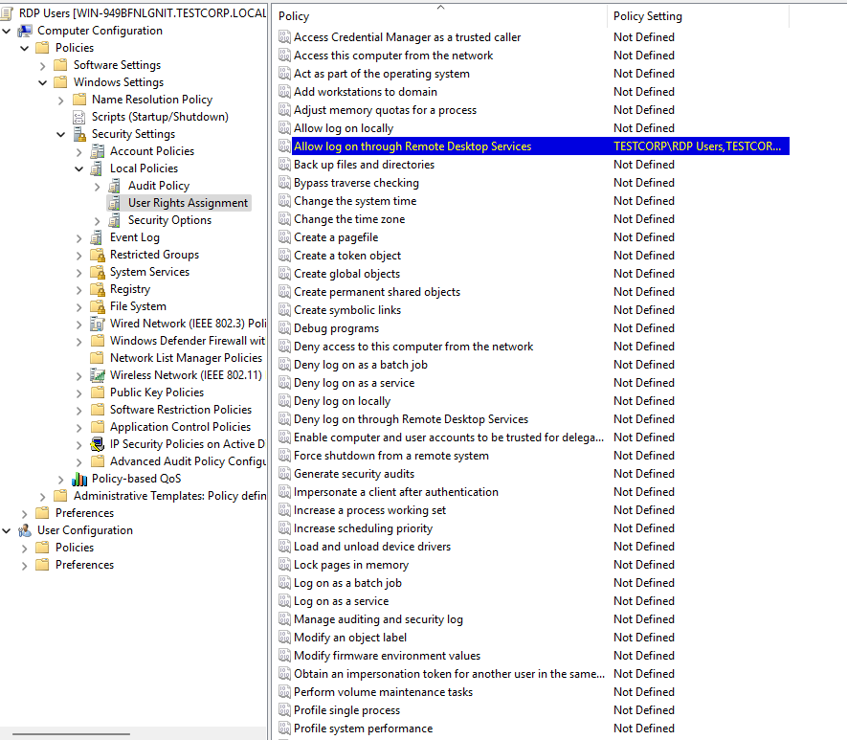
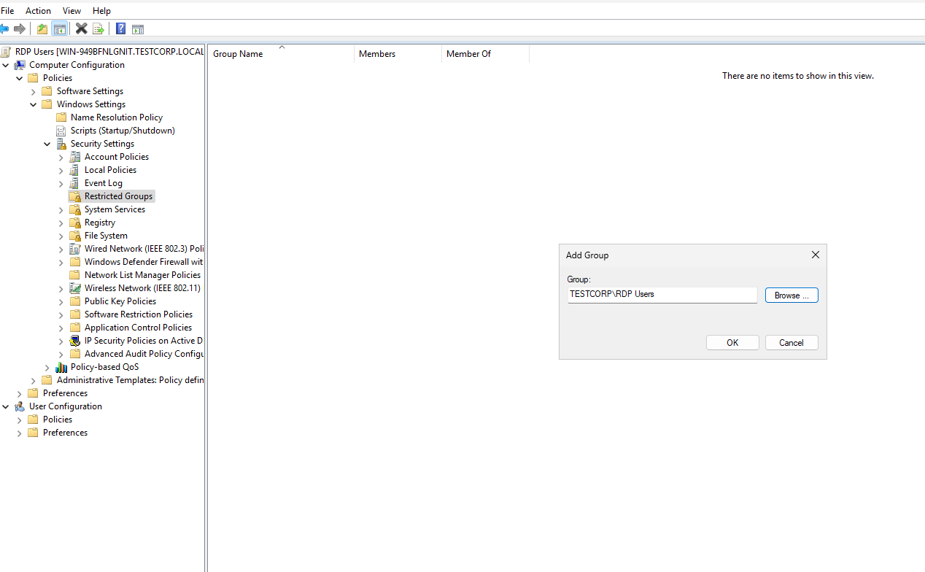
Group Policy Object Configuration
A GPO named RDP Users was created and configured to allow logon through Remote Desktop Services. The RDP Users group and Domain Admins group were added to this policy.
This configuration ensures that only Domain Admins and users explicitly added to the RDP Users group have RDP access to domain-joined computers.
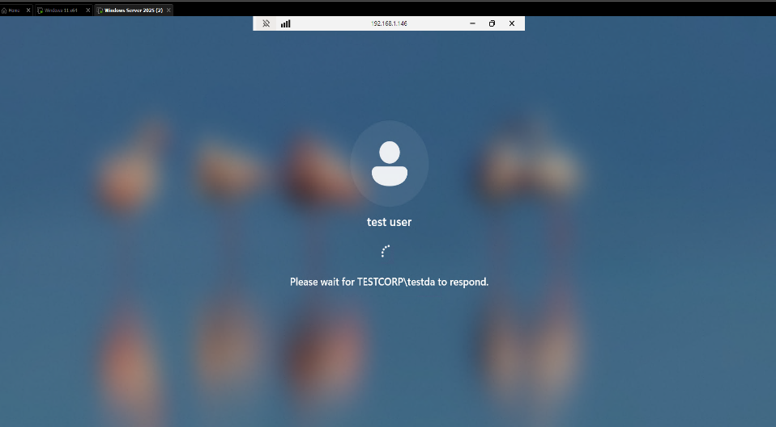
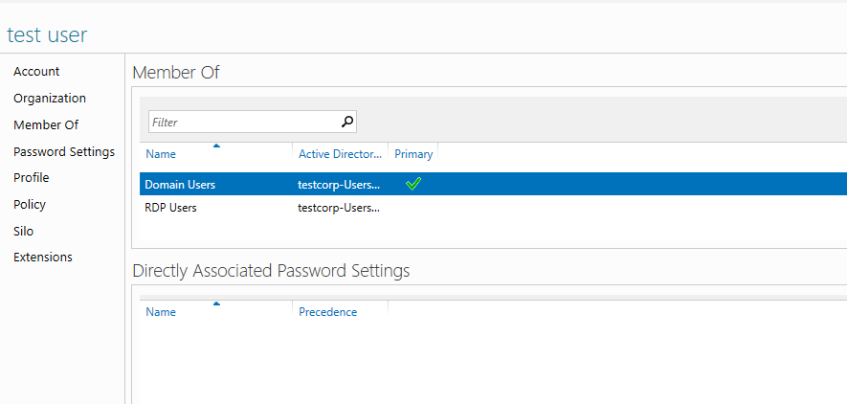
Verification
The user TestUser was added to the RDP Users group, and Remote Desktop access was successfully confirmed

